Reimagine RTS
Draft Recommendation Service Frequency

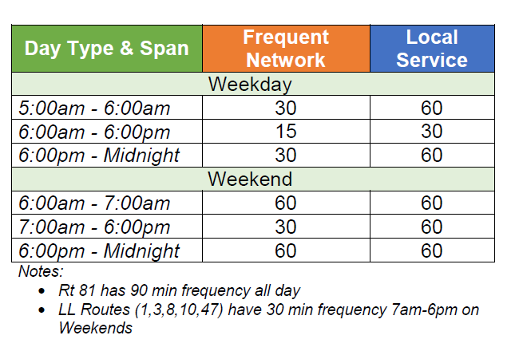

Weekdays
Weekdays from 5am to 6am, routes on the frequent network will run every 30 minutes and routes on the local service will run every 60 minutes.
Weekdays from 6am to 6pm, routes on the frequent network will run every 15 minutes and routes on the local service will run every 30 minutes.
Weekdays from 6pm to midnight, routes on the frequent network will run every 30 minutes and routes on the local service will run every 60 minutes.

Weekends
Weekends from 6am to 7 am, routes on the frequent network and the local service will run every 60 minutes.
Weekends from 7am to 6pm, routes on the frequent network will run every 30 minutes and routes on the local service will run every 60 minutes.
Weekends from 6pm to midnight, routes on the frequent network and the local service will run every 60 minutes

Notes
Route 81 will have 90 minute frequency all day, every day.
Long Line routes (Routes 1, 3, 8, 10 and 47) will have 30 minute frequency from 7am to 6pm on Weekends.

