[Grab your reader’s attention with a great quote from the document or use this space to emphasize a key point. To place this text box anywhere on the page, just drag it.]

Reimagine RTS Companion Report

This report from RTS is a companion document to the completed report from our project consultant, Transportation Management & Design, Inc. (TMD). The purpose of this report is to help answer questions about the next steps of the Reimagine RTS process and highlight specific points of feedback from the community that will be addressed in upcoming stages of the project.
When beginning the Reimagine RTS process, we asked TMD to examine the existing transit system in Monroe County and recommend a redesigned fixed-route system that aligns with the resources we have and the new reality we face. We believe TMD was successful in completing that task. While there is much the community wants that is not addressed by what TMD proposes, nearly 80% say they are satisfied or more than satisfied with the recommended fixed-route system.
In addition to reimagining how public transit operates in Monroe County, we also need to work with lawmakers to reimagine how public transit is funded. The transit system TMD recommends is within our current funding levels. We have also received many requests to make additional improvements the system, but current funding levels are not sufficient to implement them. As we work towards a final plan for the new system, we will continue working with our customers to advocate for appropriate funding for transit.

Overview
The public transit system in Monroe County has essentially been the same for decades; designed when downtown Rochester was the center of our community from every perspective. Since then, the demographics of our area have changed, the locations of employment centers have changed, and the number of available transportation options has changed. RTS has made some adjustments over time, but the structure of the transit system is the same. RTS constantly receives requests for more transit, for better transit, and for transit that is more frequent. These requests come from every corner of the county, specifically from business owners, senior citizens, millennials, individuals with disabilities, and those working to transition from poverty to prosperity. With more businesses locating to areas of our region that are not served well by public transit, if at all, we expect the demands for more to continue growing. This has created a new reality for public transit that we will not ignore.
IMAGE DESCRIPTION: Photo of the Rochester city skyline.
RTS hired TMD, a consulting firm with national transit experience, to conduct a study of the public transit system in Monroe County. TMD’s task was to identify for us what the fixed-route transit system should look like. In other words, where the 40- and 60-foot buses should go and with what frequency. Good fixed-route transit runs with regular and consistent frequency throughout the day, on weekdays and weekends. This is what TMD has recommended for the fixed-route transit system in Monroe County.
Public transit works best in a community where there is a convergence of density, diversity and design. For transit to be successful – as TMD states in their completed report – “there must be enough density to provide riders; diverse uses that generate all-day all-week demand; and streets that are designed for all modes and users. Without these key characteristics, providing efficient transit service becomes a challenge.”

Benefits of the fixed-route system recommended by tmd
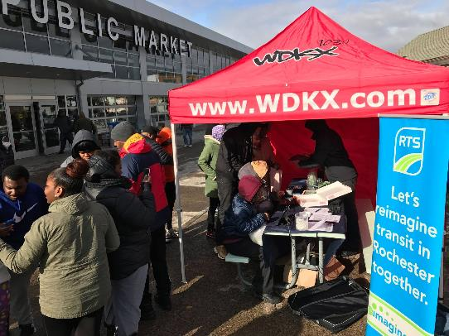
TMD’s recommendation offers RTS customers benefits that are not provided by the current system. The proposed fixed-route system offers the following:
IMAGE DESCRIPTION: Photo of customers interacting
with a Reimagine RTS/WDKX pop up booth at the Rochester Public Market.
- Ten routes with 15-minute bus service between 6am and 6pm during the week (example: Route 47 Monroe Short Line).
- Consistent coverage on weekdays and weekends – meaning the routes that run during the week will also run on the weekend.
- 95% of current customers will be within walking distance of the recommended system.
- 64% of current customers will have access to the 10 frequent routes.
In addition to offering a better design for the fixed-route system in our community, TMD’s recommendation aligns with the Rochester-Monroe Anti-Poverty Initiative recommendation of high-frequency cross-town transportation.

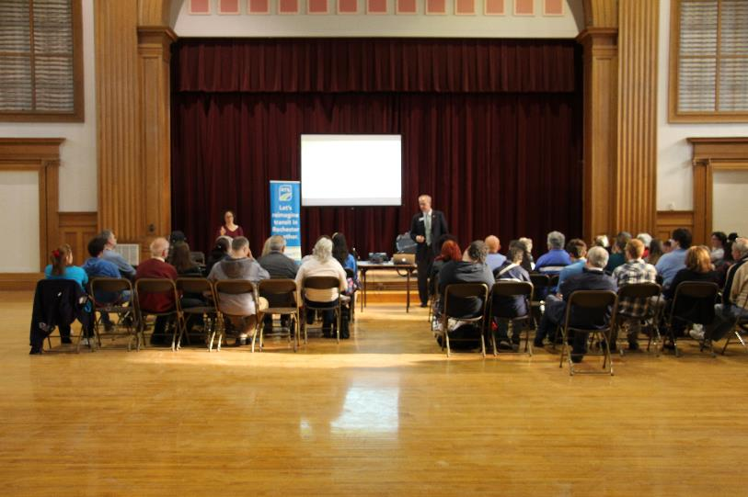
community input informed the Reimagine RTS Process
IMAGE DESCRIPTION: Photo of audience listening to CEO Bill Carpenter during Reimagine RTS information session.
Another reason the Reimagine RTS study has been successful to this point is the amount of community participation in the study process. Since the public launch of the study in September 2017, we conducted more than 150 outreach sessions with customers, employees and stakeholders. Spanish language and Sign Language interpreters were present at many of the events. We collected nearly 14,000 surveys online and in-person at the outreach sessions. We placed advertisements with newspapers, radio stations, outdoor poster boards, on the sides of buses, and on digital media. Below is a comprehensive summary of all of the advertisements and communication methods:
- Advertising Channels:
- Newspaper: Democrat and Chronicle
- Radio: WAIO-FM, WHAM-AM, WRMM-FM, WBEE-FM, WCMF-FM, WPXY-FM, WDKX-FM,
- Digital: Display, Facebook
- Outdoor: 7 Poster Boards
- Transit: Outside of 20 buses
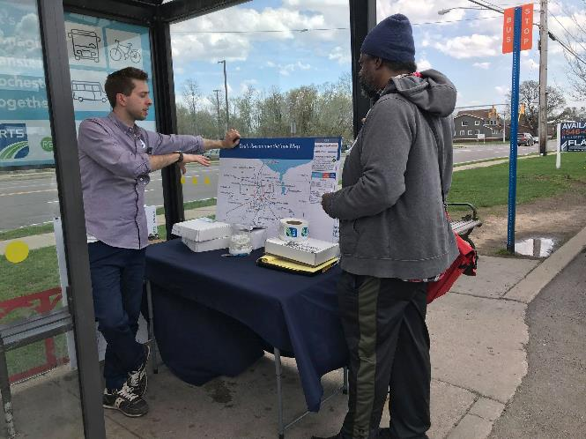
- Other Communication Channels:
IMAGE DESCRIPTION: Photo of a RTS representative speaking with a
customer about Reimagine RTS at a pop up session at the Irondequoit Plaza bus stop.
- Email Newsletter
- SMS News
- Digital Signage & Posters in Transit Center
- Brochures
- Business Cards
- Social Media (Facebook, Twitter, LinkedIn, Instagram)
- On-the-Bus Posters and Rail Cards
- Radio Spot played on buses
- Shelter Posters
- Website Information
- Overview Video
- Community Outreach - Grass Roots Efforts
- News media coverage with local print, radio and television outlets
Information was provided in other languages, including braille, when requested.

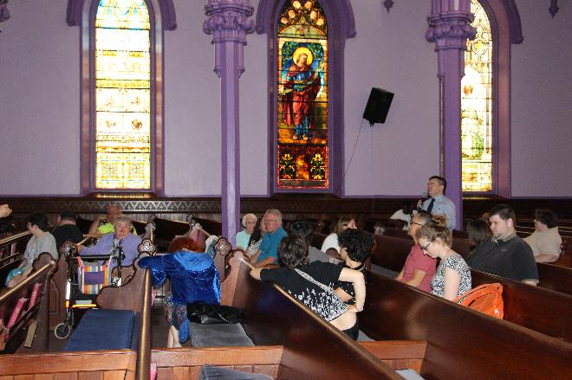
TMD applied input from RTS and information gathered during the outreach sessions during Phase 3 to improve their report and recommendation. The improvements they made include:
IMAGE DESCRIPTION: A customer speaks during a
Reimagine RTS information session held at the Central Church of Christ.
- Route 10 Dewey – Short Line and Long Line: This route has been altered to travel along Broad Street instead of State Street to create a “crosstown” connection to Southwest routes (4 Genesee, 8 Chili, 9 Jay/Maple, 19 Plymouth, 25 Thurston/MCC) at Main & Broad.
- Route 3 Lyell Short Line: This route is now the Lyell-Upper Falls Crosstown. It will travel from the Lyell Wegmans Plaza area to Portland Avenue via Lyell avenue and Upper Falls Boulevard.
- Seasonal route to Seabreeze: This route will originate from the recommended Skyview Plaza Connection Hub and will operate during the season when Seabreeze is open.
- Pittsford-Area Connection Hub: A Connection Hub near Pittsford Plaza was added.
- New Community Mobility Zone: A new Community Mobility Zone was added in the southeast part of the county.

“We Heard You” - Addressing Community Feedback
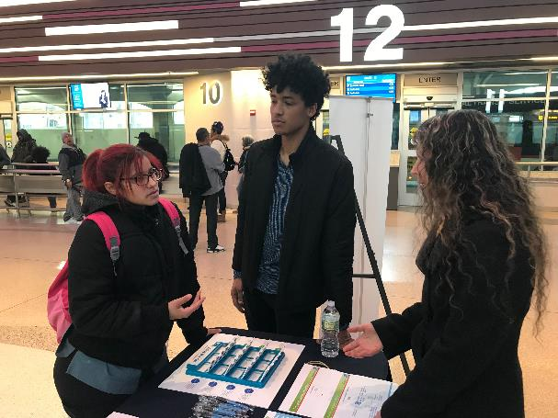
The majority of people who participated in the study process are satisfied with TMD’s recommendation. As part of the feedback we received, we heard from individuals and organizations who either want to see the recommended system do more than what TMD recommends or want improvements that do not meet the definition of an efficiently designed fixed-route system. The latter will be considered as part of our upcoming study of solutions for the Community Mobility Zones.
IMAGE DESCRIPTION: An RTS customer provides feedback to
RTS representatives at a Reimagine RTS pop up session held at the RTS Transit Center.

Here is a list of improvements that are not included in TMD’s report because funding is not currently available:
- Add routes to the frequent network;
- Add improved frequency to service on weekday evenings and weekends; and
- Maintain the existing span of service (5am to 1am).

Following is a list of improvements that will be considered as we identify solutions for the Community Mobility Zones:
- Reinstate segment of the existing Route 48 on Elmwood Avenue;
- Park and Ride/Commuter routes;
- All-day, all-year service to the Public Market and the Seneca Park Zoo;
- Reinstate fixed-route service to Summerville, and;
- Reinstate year-round service to Seabreeze.

Finalizing Solutions for the Community Mobility Zones
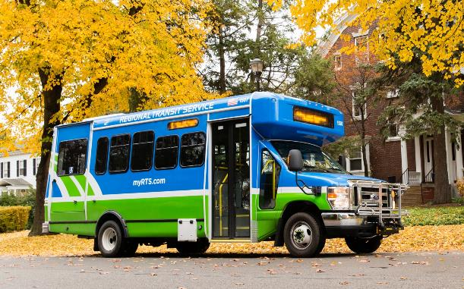
Community Mobility Zones are areas in Monroe County currently served by 40- and 60-foot buses that would be served better by one or more different transportation options. TMD identified these specific areas of focus in their completed report. Now that RTS has received the report for the fixed-route system, work has begun to determine the most effective transportation products to adopt in the Community Mobility Zones.
IMAGE DESCRIPTION: Photo of a smaller and ADA accessible bus. .
RTS is in the process of hiring a consultant to study the various transportation patterns in seven zones identified by TMD in their report. The selection and subsequent recommendation for Board approval of this consultant are planned to occur no later than October 2018. This study will include a collaborative effort between RTS staff, the consultant, customers, and stakeholders in the community. RTS expects to complete the study in early 2019, at which time we will seek additional feedback from customers and the community.

Determining Solutions for Paratransit Service
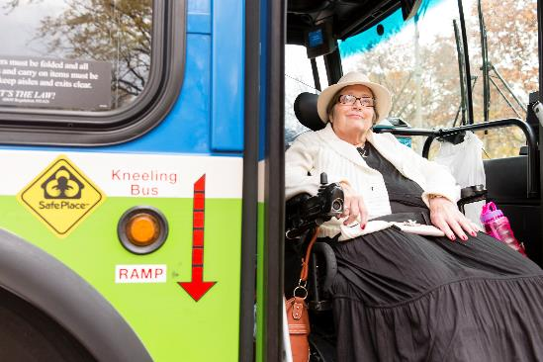
According to Federal law, the Complementary Paratransit Service Area is required within a fixed-route transit system, extending three-quarters of a mile on either side and at the end of each fixed route. If RTS changes the geography of the fixed route system, as proposed in TMD’s completed report, the Complementary Paratransit Service Area would also change. RTS management is aware of both the FTA requirement as well as the many transportation options that enable all customers to use public transit. The need for accessible public transit for all customers will be a priority as the products for the community mobility zones are identified and prioritized.
IMAGE DESCRIPTION: A photo of a customer
using a motorized wheelchair disembarks an RTS bus.
RTS will review access across the entire system (the fixed-route network and Community Mobility Zones) once the Community Mobility Zone solutions have been identified. A comprehensive paratransit solution will be determined at that time and based on additional feedback from the public.

Developing Connection Hubs
In TMD’s report, they recommend the creation of connection hubs that will help customers make the connection between the fixed-route network and the community mobility zones. When the products for each zone are determined, we will be able to identify the specific locations, designs, and infrastructure requirements for each hub. This process will also require collaboration with various businesses and municipalities in Monroe County. We anticipate having some of the hubs in place at key locations when the new system is implemented in the summer of 2020. The remaining hubs will open as soon as possible after implementation and as funding allows.

A New Approach for Business Partners
RTS has 29 business partners in Monroe County. Our approach to our work with business partners as we reimagine our public transit system is to meet the needs of our customers according to the contractual agreements we have in place. When the new system is implemented, we will work with current and future business partners to identify the solutions that best meet their needs within the realities of the reimagined system. A list of our business partners is available at myRTS.com.

Conclusion
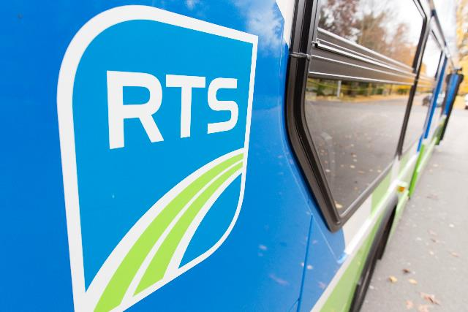
Long-term funding constraints, changing demographics, and constantly increasing expectations of public transit necessitate that we Reimagine RTS. We believe TMD’s recommendations provide our community with an improved and viable fixed-route transit system.
IMAGE DESCRIPTION: Close up photo of RTS bus featuring RTS logo.
The 40- and 60- foot buses that have been the face of public transit in our community for decades will now be part of a larger network of public transit products from which customers can choose. We anticipate serving our community with innovative solutions that result in a public transportation network that offers improved connectivity and sustainability in Monroe County for many years to come.
RTS anticipates putting forth the new system for your review in the summer of 2019, with implementation taking place in the summer of 2020.

